Phase VI

User Interface Development

AURA EVENTS & SPONSOR
College Events & Sponsor Management

1. Declarative UI Setup (Low-Code)
- The Path: Setup > App Manager & Setup > Lightning App Builder
- The Procedure:
  - Lightning App: Created the "Aura Event Management" app with a custom theme and navigation.
  - Navigation Items: Added tabs for Events, Vendors, Sponsors, and Reports.
  - Utility Bar: Implemented a persistent footer with Notes and Recent Items for multi-tasking.
  - Record Page Customization: Created a custom Financials Tab on the Event Record Page to isolate budget-related data.
- Concepts Used: App Manager, Utility Bar, Lightning App Builder, Component Visibility.

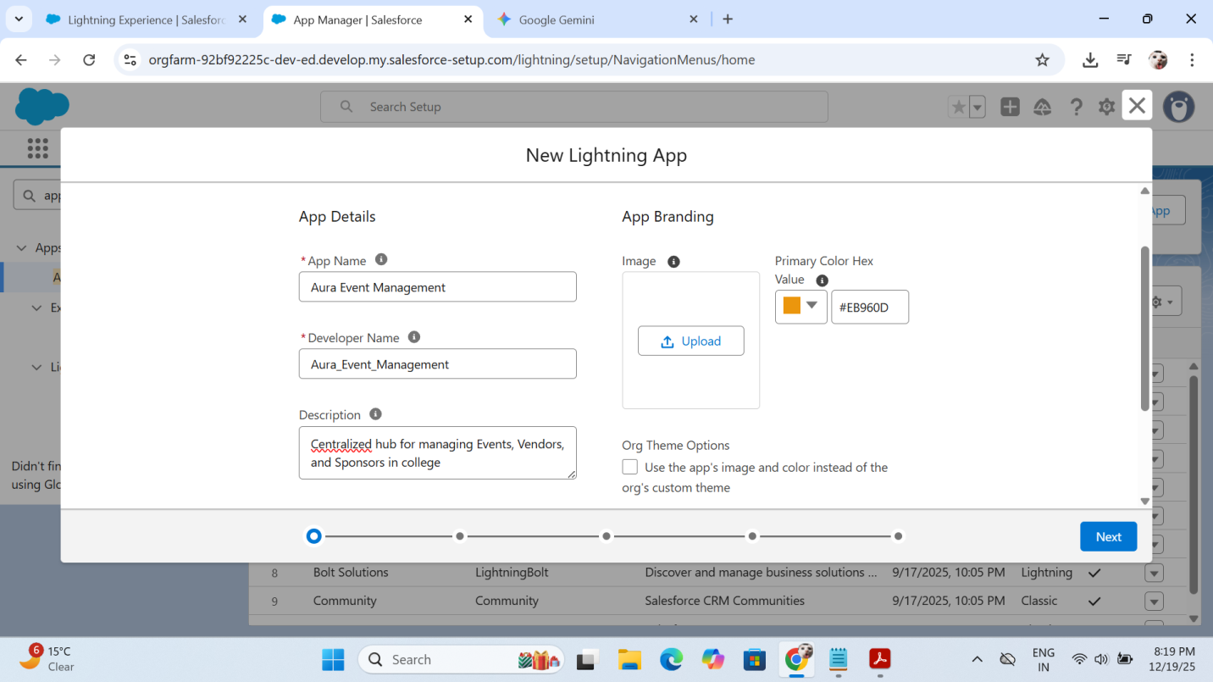

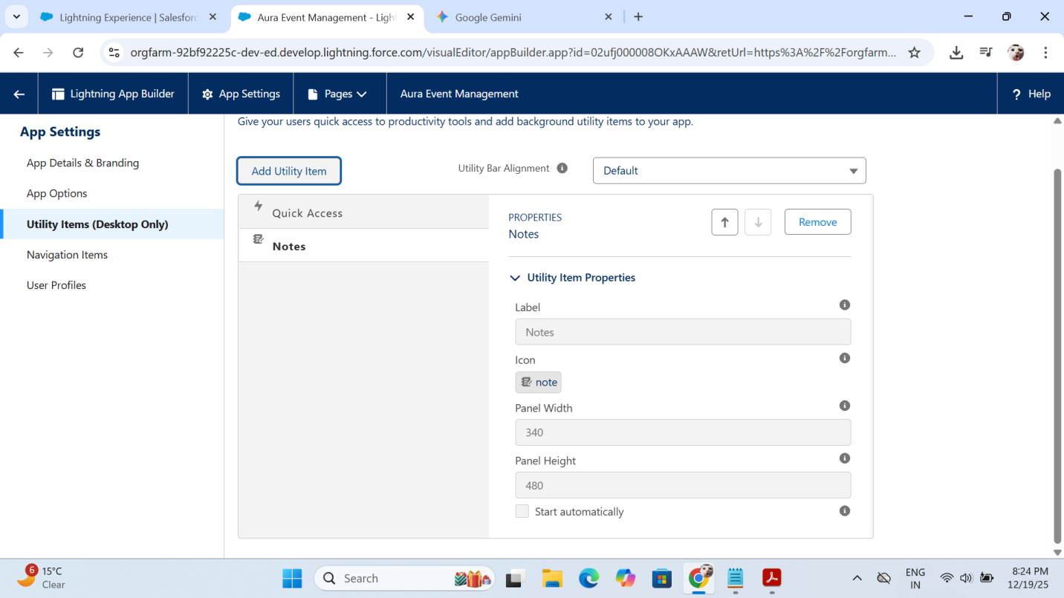

2. Apex Integration for UI (The Bridge)
To power our custom components, we created a specialized Apex controller to fetch real-time financial data.
- The Path: force-app > main > default > classes > EventSummaryController.cls
- The Procedure:
  - Developed a getEventBudgetDetails method utilizing @AuraEnabled(cacheable=true).
  - Queried the Budget__c and Total_Vendor_Cost__c fields to feed the UI.
- Concepts Used: AuraEnabled methods, SOQL in UI controllers, Data Security (with sharing).

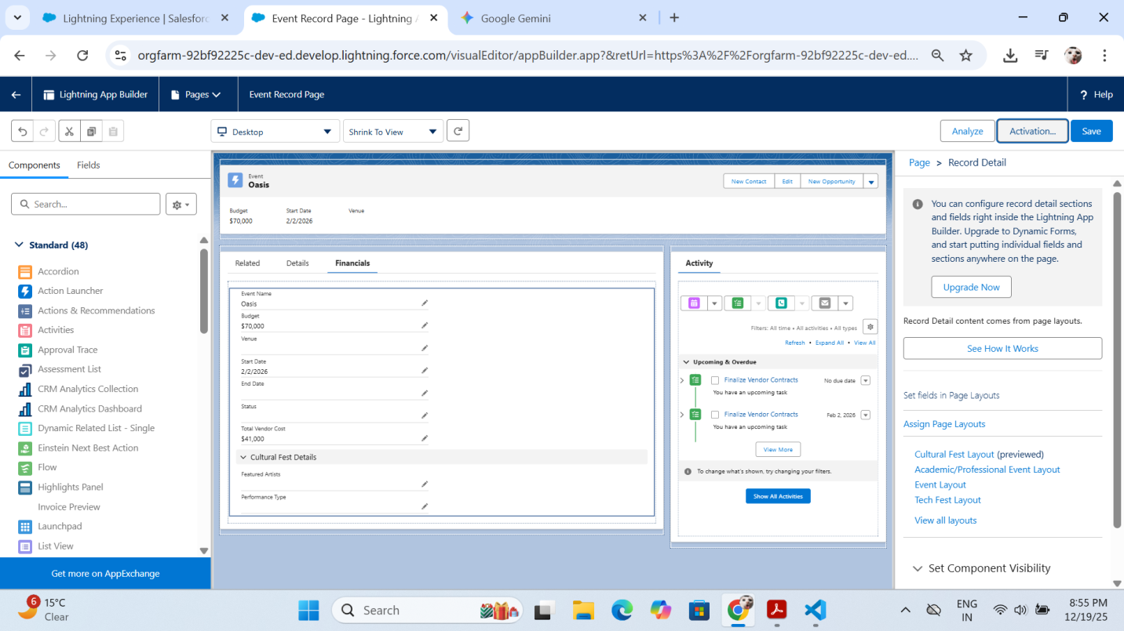

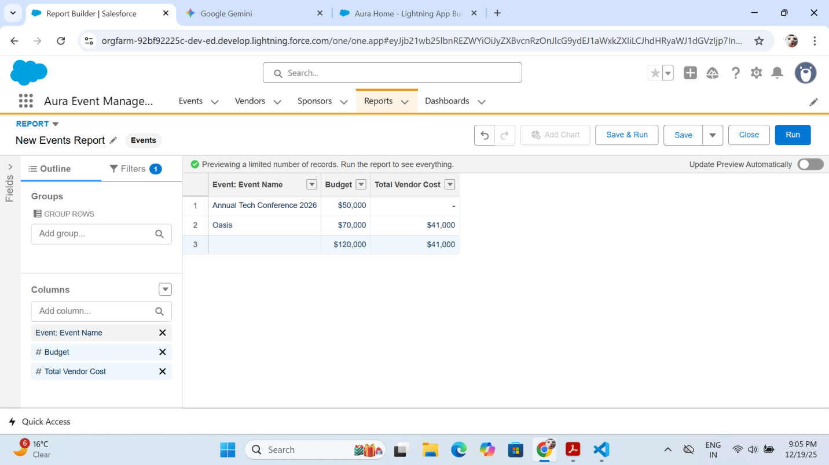

3. Lightning Web Component (LWC) Development
We built a programmatic "Financial Tracker" to give users a visual representation of their budget utilization.
- The Path: force-app > main > default > lwc > eventBudgetTracker
- The Procedure:
  - HTML: Designed a card-based layout featuring a lightning-progress-bar.
  - JS (Wire Service): Used the @wire adapter to automatically fetch data based on the current recordId.
  - JS (Reactive Logic): Created a getter (percentageUsed) to calculate progress dynamically.
  - Metadata: Configured the .js-meta.xml to expose the component specifically for lightning__RecordPage.
- Concepts Used: LWC Lifecycle, Wire Service, Decorators (@api, @wire), Progress Bar component.
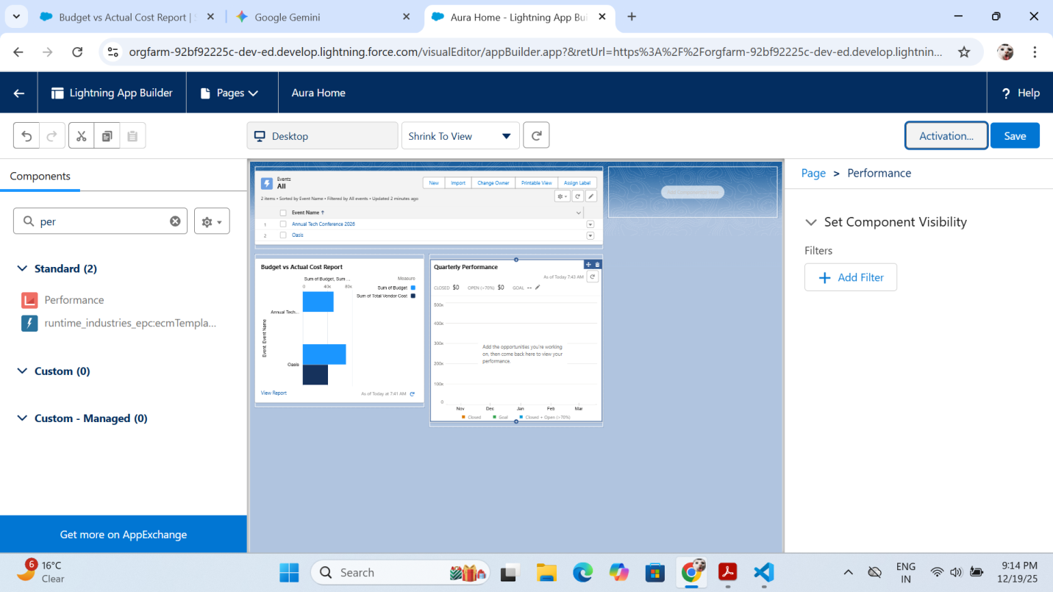

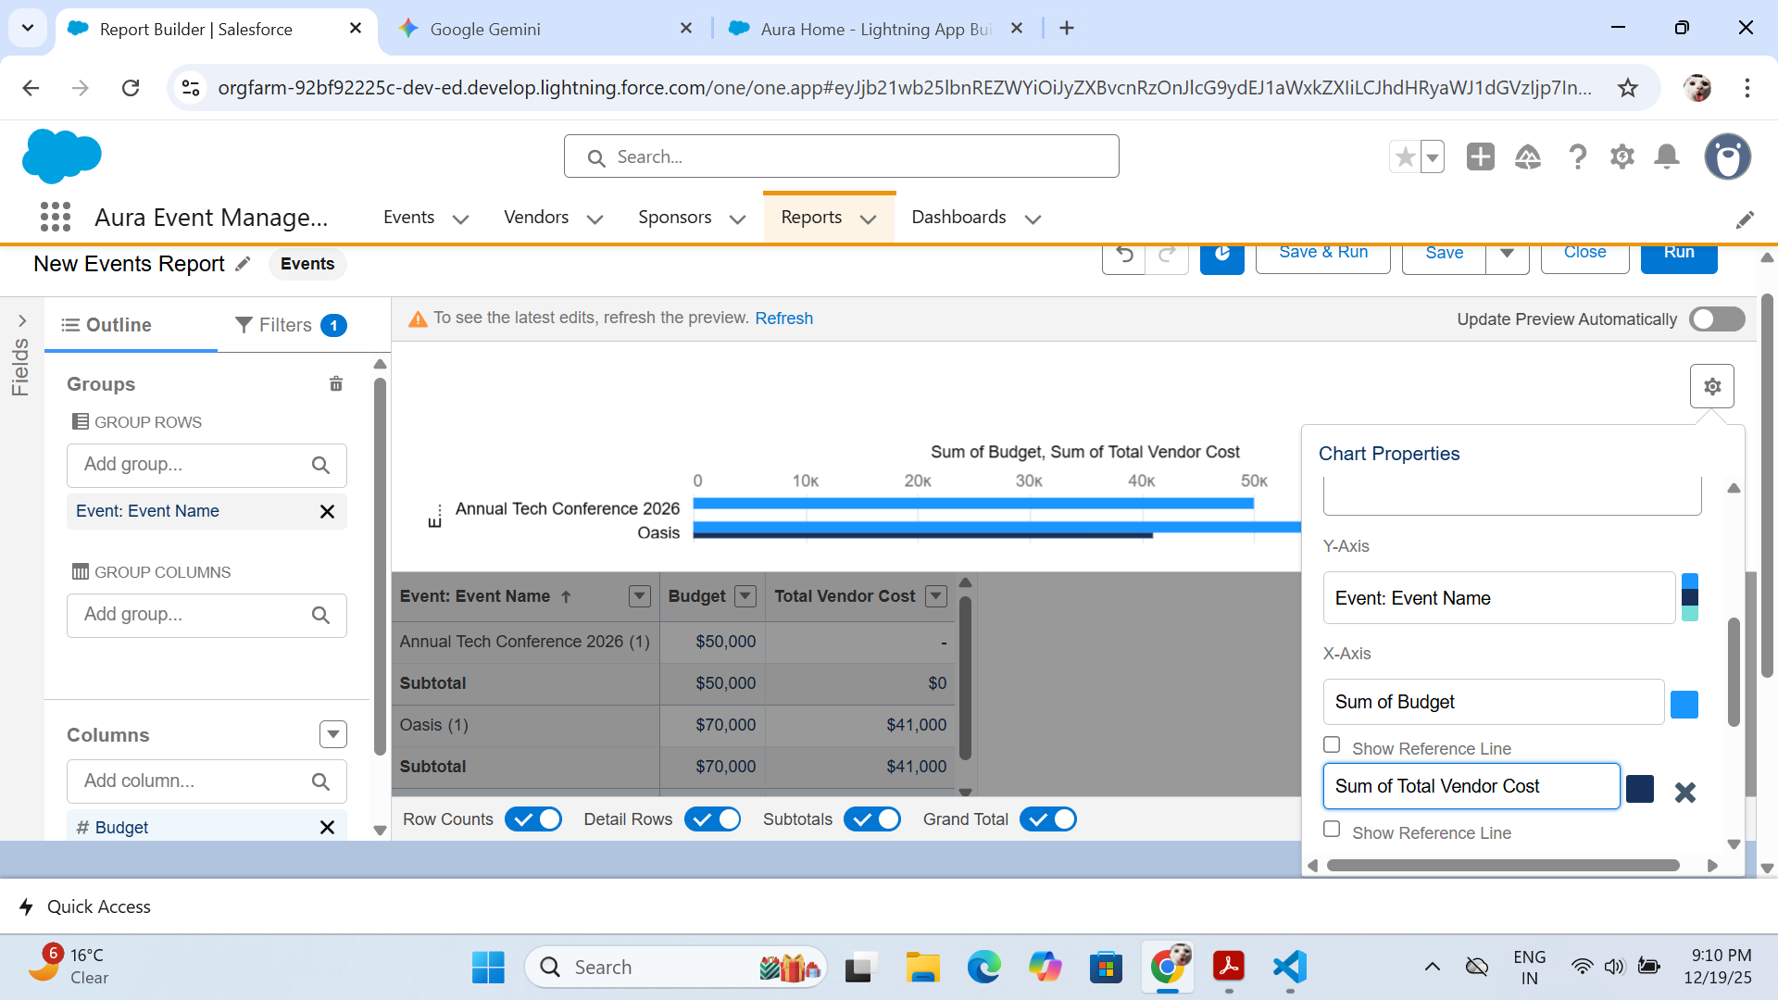

4. Advanced LWC Interactivity & Navigation
We upgraded the component to be more than just a display—making it an interactive tool.
- The Path: eventBudgetTracker.js & eventBudgetTracker.html
- The Procedure:
  - Navigation Service: Imported NavigationMixin to allow users to jump directly to the Related Vendor List via a button.
  - Imperative Apex: Added a "Refresh Totals" button using refreshApex to bypass cache and show immediate updates after "re-kicking" triggers.
  - Event Communication: Established the pattern for CustomEvent and dispatchEvent to allow potential child components to communicate with the tracker.
- Concepts Used: NavigationMixin, Imperative Apex calls, refreshApex, Custom Events (DOM bubbling).

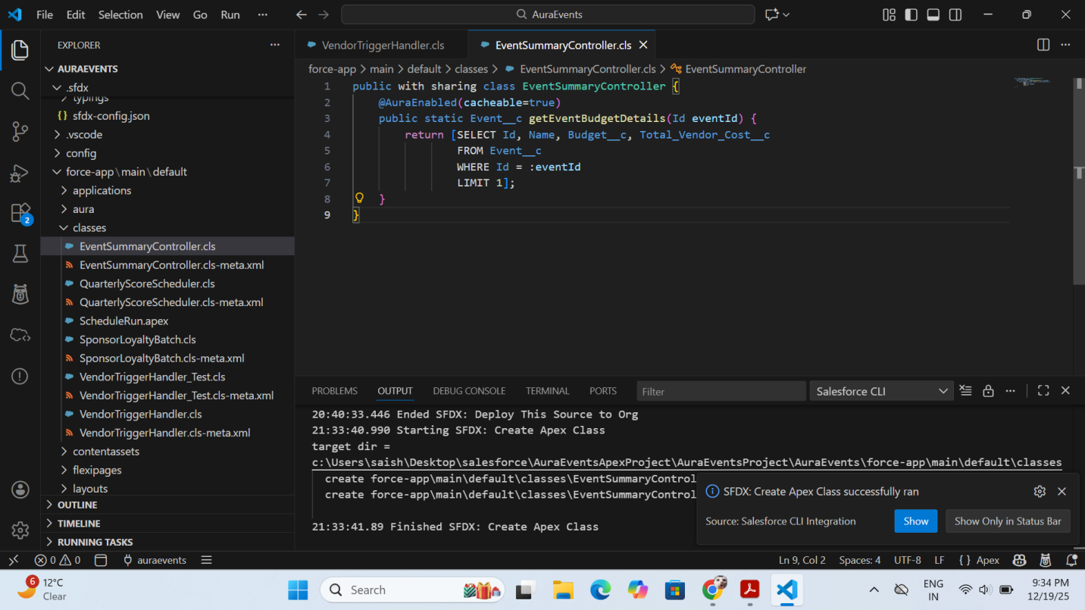

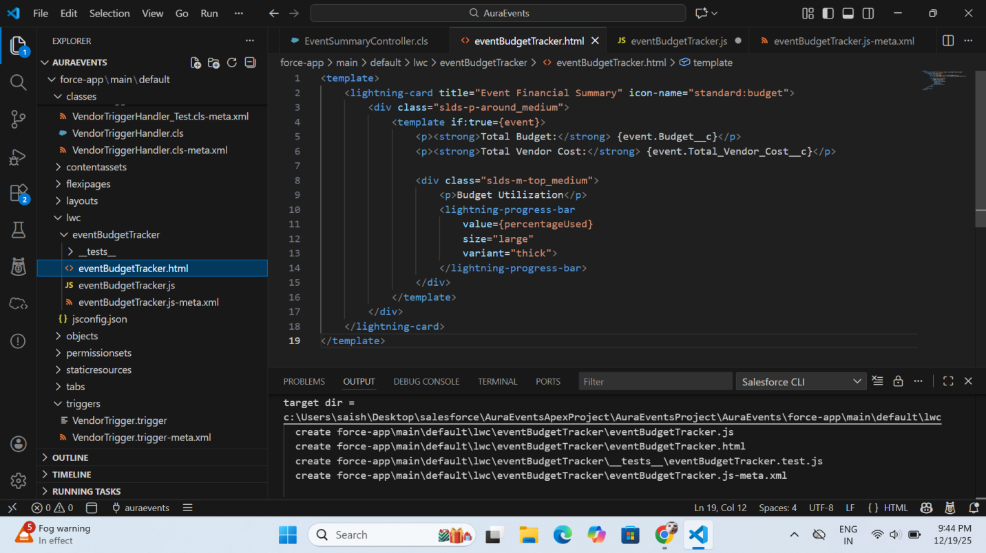

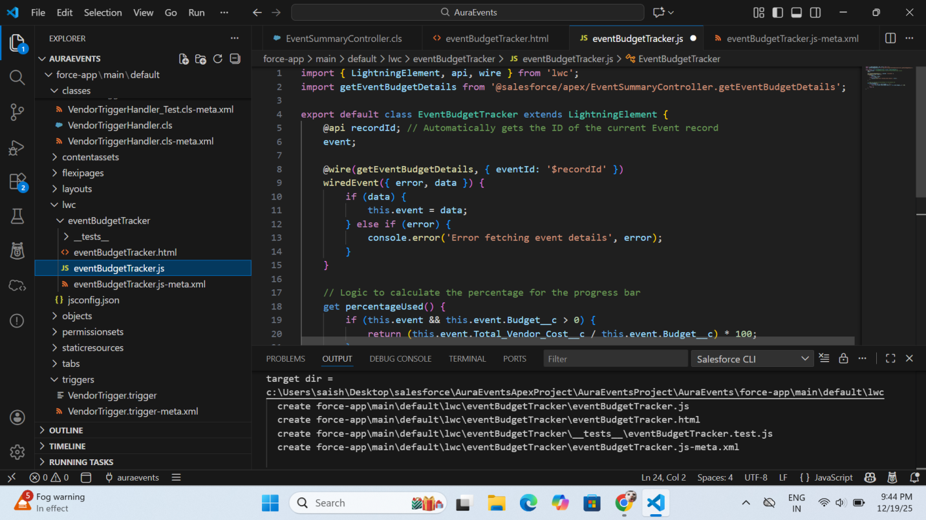

5. Data Verification & Troubleshooting
You successfully managed the transition from "Empty Fields" to a "Live Dashboard" by troubleshooting the underlying data layer.
- What was done:
  - Method Visibility Fix: Updated VendorTriggerHandler.aggregateVendorCosts from private to public to allow external access.
  - Deployment Resolution: Resolved the "Jobs Pending" error by deleting scheduled jobs in Setup, allowing for a clean deployment.
  - The Re-Kick Script: Executed an anonymous Apex script to force-calculate existing records, successfully updating your Event's Total Vendor Cost to $28,000.
  - UI Validation: Verified that the LWC progress bar correctly displays 56% utilization based on your $50,000 budget.

